**Literature Review**

Researched about Existing system that compare to Our Hotel system App.

Online Hotel System Reservation App that I have researched for those are –

* **1] Cloud beds Reservation System** – This app is multi task that can connect to hundred of channels from your property such as booking.com and Orbitz and it allow guests to make direct booking from their desktop, phone and through Facebook so, this app so handy and gives good impact for small business e.g. - Hotel and Motel.
* Easy to use and 24/7
* Customer support online
* Credit card system integrated by third parties.

**What we would like to improve or add in the future for our system.**

* Online support
* We would add payment from credit card in the future.

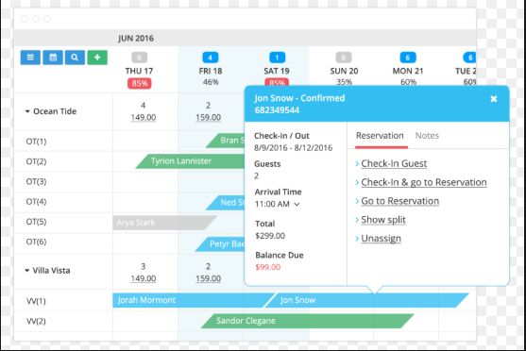

**2] eZee Front Desk –** App is mainly used by small lodge, hotel and motel and company claim that app is using in 140 countries all around the world and more than 1 million transaction in a day and across hotel management property resulting in 90,000 room manged and 70,500 users by eZee Front Desk app.

* Receive application report on phone and tablets.
* Event Management.
* Self-service check in Kiosk.

**What we would like to improve or add in the future for our system.**

* We could add any language pack based on Client majority.
* Online help.

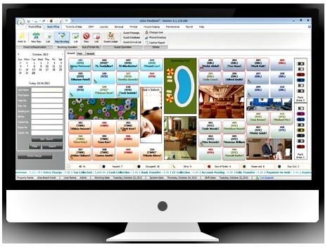

**Risk and Mitigation**

* **Lack of Experience and Skills-** Lack of experienced our team has only one software developer and required to create a Hotel reservation app its big job for us as a team to produce app and that’s going to be challenging. We simply lack expertise but we both Networking student will try our best to help our Developer out during these 8 weeks to make efficient app for our staff.

**Mitigation-** Discussion with senior Software developer and learning from them, what need to be done on time as of Knowledge side it doesn’t matter who’s is younger or older it all about asking and doing own research putting effort so, I think If developer could do that it would be another chance to gain some more experience and adding skills.

* **Technology Failure**-If technology is failing could put huge failure impact on project as we all know system could be fail at any time and that cause a massive loss to our group through technology as technology has number of good reason but never know what could have happened to machine in couple of second because all work is going to be save on our computer.

**Mitigation-** All we can do to have a backup on a different computer at the same while doing a project that’s the only way we could save our work or on Google Drive.

* **Miscommunication**- Bad communication is the biggest thing especially when doing a project work with different members as we all know ned to know what the task are of another member. Improper communication could lead to fail project or Assignment and give unnecessary problem that we don’t want especially, when you have only 8 weeks to create an app so, Communication must be good between members.

**Mitigation-** Having meeting with your group members exclude class meeting trying to make a time for them and that would help everyone to lead successful project

* **Time**- Our group is very inexperienced regards of creating a hotel reservation app for our group and only have 8 weeks to do so. We could be fall behind in this project due to lack of experience and we never done like this before so, it’s so new for us that could reach failure to reach our milestone or could be fail the project.

**Mitigation-**  It’s important that we distribute our task between members so, everyone has fair chance to do during time given as time is super crucial for this project because no body want to fail this course so, every single member need to use time very efficiently to have nice impact on our project.

**Conclusion**

As we our young developer trying to achieve our goal that have given to us by our Lecturer and we still believe our group has potential to succeed in this project and have nice celebration afterwards as developer we need to push our self to achieve something in the industry to make an impact for future generation to m make their lives better.

**References**

Taylor, D. (2018, Jan 2nd). *The 11 Most Popular Hotel Management Software Solutions for Small Hotels Compared*. Retrieved from Capterra: https://blog.capterra.com/the-5-most-popular-hotel-management-software-solutions-for-small-hotels-compared/

USA, c. C.-(.-1. (2012). *Cloudbeds*. Retrieved from Capterra: https://www.capterra.com/p/158839/Cloudbeds/